**Git Installation and SetUp**

Git is a version control system for tracking changes in computer files.It is generally used for source code management in software development

Multiple Developers can work on it

­­­­­­­­­­­

Push Operation 🡪

<--Push Operation

Push Operation

Update Operations

Clone Operation

Ammend & Push

**Commit Changes**

Commit & Push

Status and Diff Operations

Edit,Add,Move File

**Review Changes**

**Review Changes**

**Modify Wrong Copy**

**Working Copy**

**Git Server**

## Git Basic Workflow

Commit

**Staging Files to Staging Area**

**Working Directory**

**Git Repository**

Checkout the changes to have the latest version

Git Installation Steps :

Download Git and Install it

Installation Steps and Link is provided in this video :- <https://www.youtube.com/watch?v=J_Clau1bYco>

After Completing the steps You will Git the Git bash terminal

Git Commands:

Navigate to your Project Folder and open that folder and Right Click You will get an option “Git Bash”

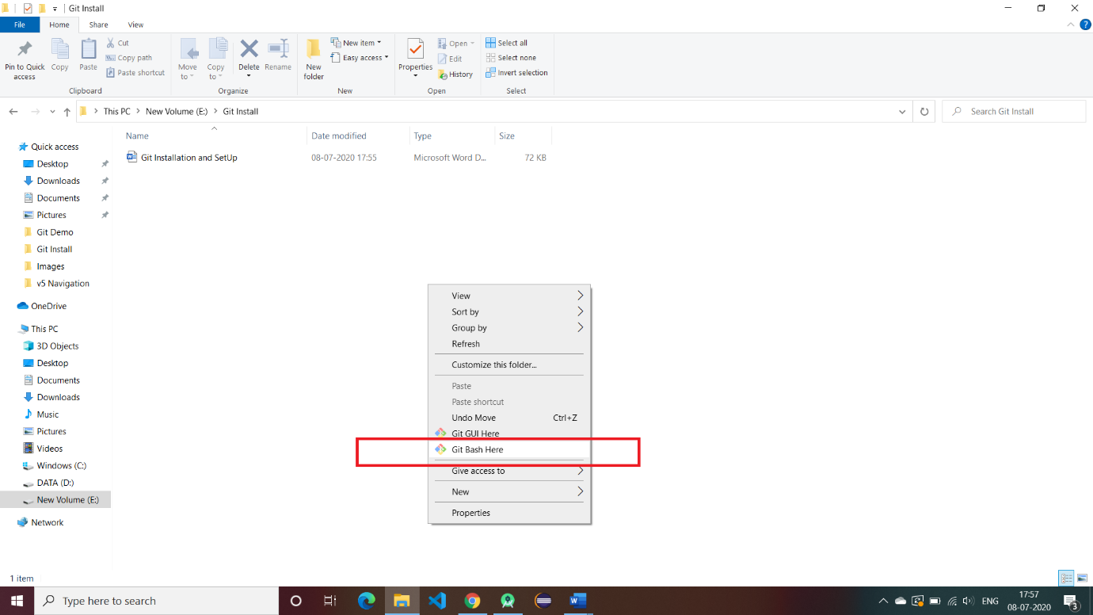

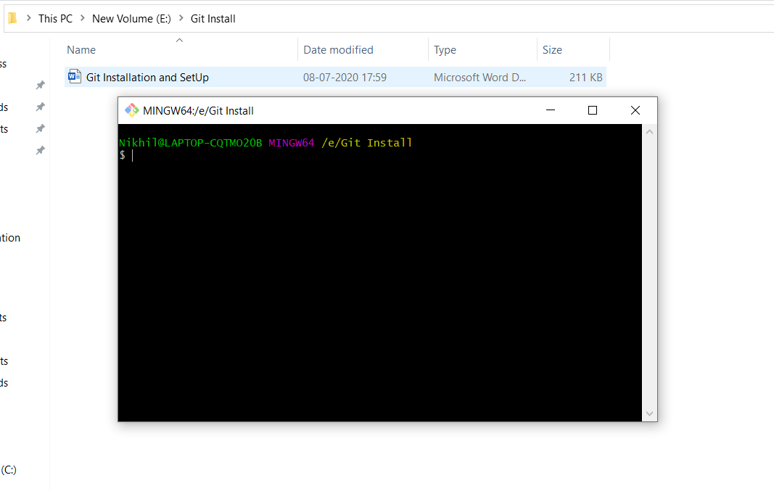

1 . Check the Git version :

git --version

2. use Username from your Git hub account official website and set it in command line

git config --global user.name "induS4"

3.use Email Account also :

git config --global user.email 'indira.thevar04@gmail.com'

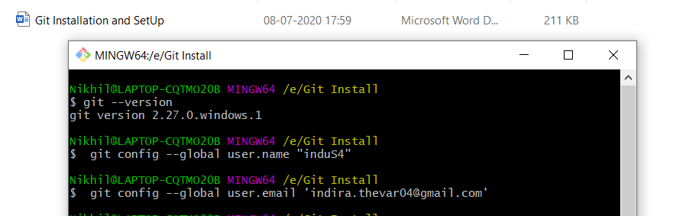

4.Verify your account using config –list command

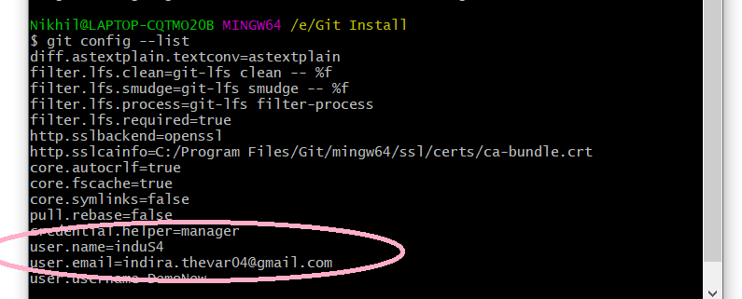

5.Initialize git in your current folder:

$ git init

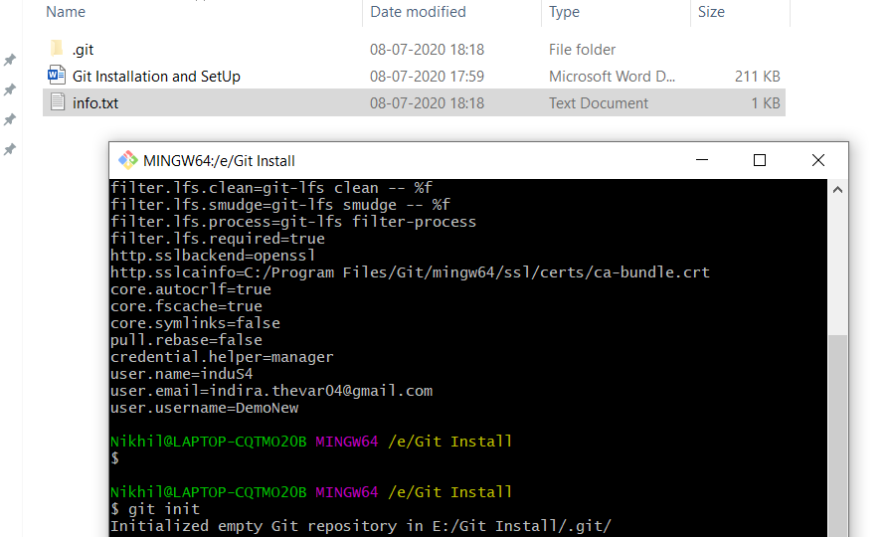

6. next command is status command to check the number of files to be committed (in Red Mark)

$ git status

